


MS Dynamics GP – QSSI POWERHOUSE WMS Integration
Deployment Checklist

Table of Contents
Version Information 2
Checklist 3
1. Make sure to turn off the Powerhouse Dynamics GP Integration Service 3
2. Create the Integration Tables 3
3. Update the values in the Integration Setup window 3
4. Setup the Location Mapping 3
5. Update the BSP.DynamicsGP.Powerhouse.dll.config file 3
6. Update the BSP.PowerHouse.DynamicsGP.Integration.exe.config file 4
7. Start the Powerhouse Dynamics GP Integration Service 4

Version Information
Version | Resource | Date | Remarks
1.0 | Ric Paras | May 21, 2020 | Created Document

Checklist

Make sure to turn off the Powerhouse Dynamics GP Integration Service
- Go to Windows Services > Powerhouse Dynamics GP Integration Service.
- Press the Stop the Service option.
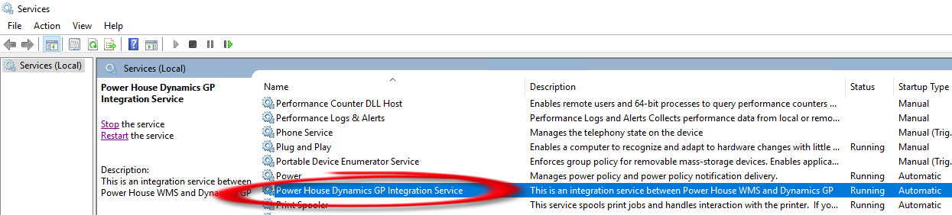
Powerhouse Dynamics GP Integration Service

Create the Integration Tables
Refer to the Integration Setup > Creating Tables chapter in the Reference Document for more information on how to create the tables.

Update the values in the Integration Setup window
Refer to the Integration Setup > Powerhouse Integration Setup Window in the Reference Document for more information.
URL Port is http://18.224.66.250:8082/PHWebServices/services/PHWebServices?wsdl
Make sure the userid and password are correct.
Make sure that the batches exist.

Setup the Location Mapping
Refer to the Integration Setup > Powerhouse Location Mapping Window in the Reference Document for more information.

Make sure the QSSI user has access to the REGAL company and has the same security access as in the TEST (WMS) company
Check both the User Security Setup and User Access Setup in GP.

Update the BSP.DynamicsGP.Powerhouse.dll.config file
- Navigate to Dynamics GP folder > Addins > BSP.DynamicsGP.Powerhouse.dll.config.
- Open it in notepad or any text editor.
- Replace the value for the BSP_DynamicsGP_PowerHouse_PowerhouseWS_PHWebServices setting to reflect the PROD URL port (http://18.224.66.250:8082/PHWebServices/services/PHWebServices.PHWebServicesHttpSoap11Endpoint).
- Save the file.

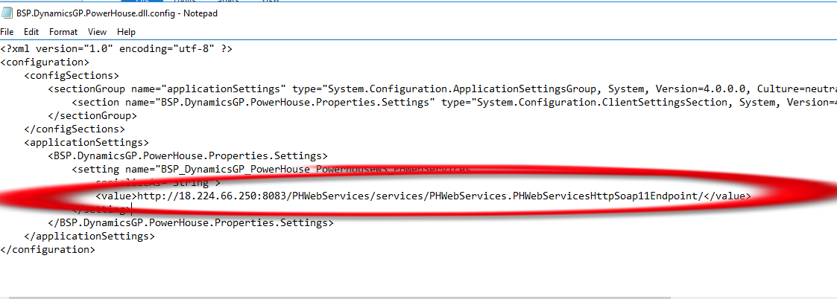
BSP.DynamicsGP.Powerhouse.dll.config file

Update the BSP.PowerHouse.DynamicsGP.Integration.exe.config file
- Navigate to C Drive > Download > BSP > QSSI > Service > BSP.PowerHouse.DynamicsGP.Integration.exe.config.
- Open it in notepad or any text editor.
- Replace the following values:

GPCompanyID - Set to 1
GPCompanyName - Set to Regal+Art+and+Gift

GPConnectionString - Replace Initial Catalog=WMS to Initial Catalog=REGAL

Endpoint address - Replace http://18.224.66.250:8083 to http://18.224.66.250:8082
- Save the file.

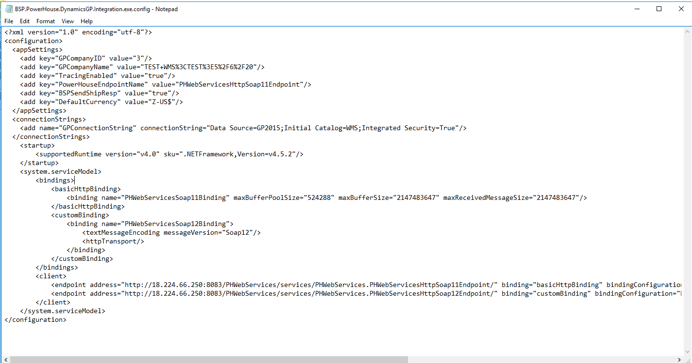
BSP.PowerHouse.DynamicsGP.Integration.exe.config file

Start the Powerhouse Dynamics GP Integration Service
- Go to Windows Services > Powerhouse Dynamics GP Integration Service.
- Press the Start the Service option.

